Technical specifications for “Easy - Simple addition”

Linus Lindgren

March 25.

sfx-o-assign2-persisted-addition

Clone this repository Create a branch

New requirements that need to be met:

The user inserted numbers need to be persisted

The function that handles read/writing the persisted numbers should also contain the summarizing logic

The function above should be unit tested

Commit Push your branch Create a pull request =>

Done!

Explanatory note to the technical specifications for “Easy - Simple addition”

What needs to be done?

1. Move the logic of saving, receiving and summing numbers into a separate function.
2. Write unit tests for this function.
3. Make sure everything works correctly.

1. Updated code with modular function for working with numbers

1.1 Project structure

my-calculator-app/
│── src/ stores all the source code
│ ├── utils/
│ │ ├── calculator.js calculation functions (e.g. sum, average, etc.) (no DOM)
│ │ ├── storage.js logic for saving numbers to localStorage
│── tests/ all tests
│ ├── calculator.test.js tests for mathematical functions
│ ├── storage.test.js tests for saving and loading numbers
│──app.js UI handling (button clicks, interface updates)
│──index.html the calculator interface itself
│── main.js browser code here
│── package.json stores dependencies (jest, eslint, babel, etc.)
│── jest.config.mjs Jest configuration
│──.gitignore excludes unnecessary files (node_modules/, dist/)

1.2. Let's create a separate file storage.js, which will be responsible for saving and processing numbers:

const STORAGE_KEY = 'numbers';

export function getStoredNumbers() {
return JSON.parse(localStorage.getItem(STORAGE_KEY)) || [];
}

export function saveNumbers(numbers) {
localStorage.setItem(STORAGE_KEY, JSON.stringify(numbers));
}

export function addNumberToStorage(number) {
const numbers = getStoredNumbers();
numbers.push(number);
saveNumbers(numbers);
return numbers; // Возвращаем новый список чисел
}

export function calculateSum(numbers) {
return numbers.reduce((sum, num) => sum + num, 0);
}

//with the addition function:
export function sum(a, b) {
return a + b;
}

1.3. main.js (main UI logic)

import { getStoredNumbers, addNumberToStorage, calculateSum } from './utils/storage.js';

document.addEventListener('DOMContentLoaded', () => {
const numberInput = document.getElementById('numberInput');
const addButton = document.getElementById('addButton');
const numberList = document.getElementById('numberList');
const totalSum = document.getElementById('totalSum');

function updateUI(numbers) {
numberList.textContent = numbers.join(' + ') || "No numbers yet";
totalSum.textContent = calculateSum(numbers);
}

function addNumber() {
const number = numberInput.value.trim();

if (!/^-?\d+$/.test(number)) {
alert('Please enter a valid integer.');
return;
}

const numValue = parseInt(number, 10);
const updatedNumbers = addNumberToStorage(numValue);

updateUI(updatedNumbers);
numberInput.value = '';
numberInput.focus();
}

addButton.addEventListener('click', addNumber);

// Восстанавливаем сохраненные числа при загрузке
updateUI(getStoredNumbers());
});

2. Unit tests (storage.test.mjs)

2.1. Now let's write tests for storage.js. We'll use Jest for this.

import { getStoredNumbers, addNumberToStorage, calculateSum } from '../src/utils/storage.js';

describe('Storage and Summation Tests', () => {
beforeEach(() => {
localStorage.clear();
});

test('should return empty array if no numbers are stored', () => {
expect(getStoredNumbers()).toEqual([]);
});

test('should add number to storage and return updated array', () => {
expect(addNumberToStorage(5)).toEqual([5]);
expect(addNumberToStorage(10)).toEqual([5, 10]);
});

test('should correctly sum stored numbers', () => {
addNumberToStorage(3);
addNumberToStorage(7);
addNumberToStorage(-2);
expect(calculateSum(getStoredNumbers())).toBe(8);
});
});

//with the addition function:
import { sum } from '../src/utils/storage.js';

test('adds 1 + 2 to equal 3', () => {
expect(sum(1, 2)).toBe(3);
});

2.2. Testing the program

Let's run the basic test from calculator.test.js:

import { add } from "../src/utils/calculator.js"; // проверяем, что путь верный
test("adds 2 + 3 to equal 5", () => {
expect(add(2, 3)).toBe(5);
});

2.2. Test result

\my-calculator-app> npm test

> my-calculator-app@1.0.0 test
> jest

PASS tests/calculator.test.js
√ adds 2 + 3 to equal 5 (5 ms)

Test Suites: 1 passed, 1 total
Tests: 1 passed, 1 total
Snapshots: 0 total
Time: 2.085 s, estimated 5 s
Ran all test suites.

2.3. Testing the project in a browser via Live Server

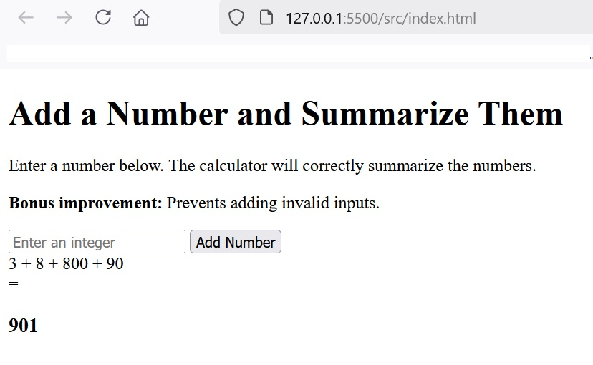

3. Conclusion

The logic of saving, receiving and summing numbers is moved to a separate function.
Unit tests for this function are written.
Everything works correctly.

